**Write a code to implement power function in O(log n) time complexity.**

**Student Name: Rahul Kumar Singh UID:19BCS8016**

**Branch:** CSE **Section/Group:**26-A

**Semester:** 5th  **Date of Performance:**30th July 2020

**Subject Name** Top of Form

**Subject Code:**CSP-309

**1. Aim/Overview of the practical:**

Write a code to implement power function in O(log n) time complexity.

**2. Task to be done/ Which logistics used:**

Using Divide and Conqueror to calculate power function in O(log n) time complexity.

**3. Algorithm/Flowchart (For programming based labs):**

**Step:1** power(int x, int y)

{

If (y == 0)

{

return 1;

}

**Step:2** if (y < 0)

{

return 1/power

}

**Step:3** if(y % 2 == 0)

{

return power(x, y/2) * power(x, y/2)

**Step:4** else

{

Return x * power(x, y/2) * power(x, y/2)

}

**4. Steps for experiment/practical/Code:**

def power(x, y):

if (y == 0):

return 1

elif (int(y % 2) == 0):

return (power(x, int(y / 2))* power(x, int(y / 2)))

elif (y < 0):

return 1/power(x, -y)

else:

return (x * power(x, int(y / 2)) * power(x, int(y / 2)))

x = 2; y = -9

print(power (x, y))

**5. Observations/Discussions/ Complexity Analysis:**

I’m using divide and conqueror algorithm to find time complexity in O(log n).we can solve power function using many algorithm but we did’t get the complexity in order of O(log n).

**6. Result/Output/Writing Summary:**

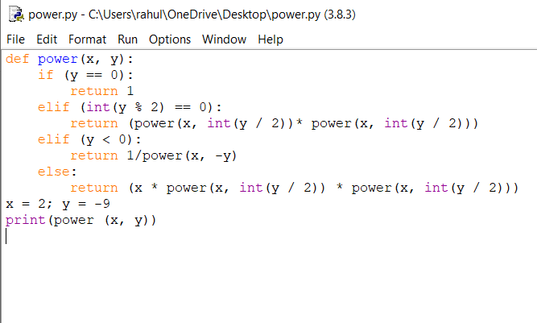

**Output:**

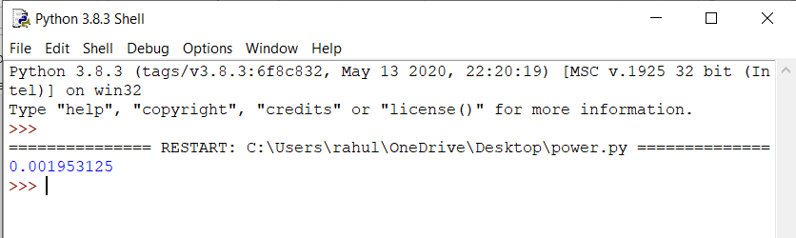

**Learning outcomes (What I have learnt):**

**1.**Learn that how to program divide and conqueror algorithm.

**2.**This will take the less time complexity.

**3.**using divide and conqueror we can quickly find the power.